***Note****: About 3 years back on World Bank Data Analysis using World Development Indicators (WDI) & gVisMotionCharts. But the motion charts stopped working  some time ago. I have always been wanting to fix this and I now got to actually doing it. The issue was 2 of the WDI indicators had changed. After fixed , I was able to host the generated motion chart. Please make sure that you enable* **flash player** *if you open the motion charts with Google Chrome. You may also have to enable* **flash** *if using Firefox, IE etc*

**Introduction**

In this post, I recreate some of the Gapminder charts with the help of R packages WDI and googleVis.  googleVis provides motion charts with which you can animate the data.

library(WDI)

library(ggplot2)

library(googleVis)

library(plyr)

**1.Get the data from 1960 to 2019 for the following**

1. Population – SP.POP.TOTL
2. GDP in US $ – [NY.GDP.MKTP.CD](http://NY.GDP.MKTP.CD)
3. Life Expectancy at birth (Years) – [SP.DYN.LE00.IN](http://SP.DYN.LE00.IN)
4. GDP Per capita income – [NY.GDP.PCAP.PP.CD](http://NY.GDP.PCAP.PP.CD)
5. Fertility rate (Births per woman) – [SP.DYN.TFRT.IN](http://SP.DYN.TFRT.IN)
6. Poverty headcount ratio – SI.POV.NAHC

# World population total

population = WDI(indicator='SP.POP.TOTL', country="all",start=1960, end=2019)

# GDP in US $

gdp= WDI(indicator='[NY.GDP.MKTP.CD](http://NY.GDP.MKTP.CD)', country="all",start=1960, end=2019)

# Life expectancy at birth (Years)

lifeExpectancy= WDI(indicator='[SP.DYN.LE00.IN](http://SP.DYN.LE00.IN)', country="all",start=1960, end=2019)

# GDP Per capita

income = WDI(indicator='[NY.GDP.PCAP.PP.CD](http://NY.GDP.PCAP.PP.CD)', country="all",start=1960, end=2019)

# Fertility rate (births per woman)

fertility = WDI(indicator='[SP.DYN.TFRT.IN](http://SP.DYN.TFRT.IN)', country="all",start=1960, end=2019)

# Poverty head count

poverty= WDI(indicator='SI.POV.NAHC', country="all",start=1960, end=2019)

**2.Rename the columns**

names(population)[3]="Total population"

names(lifeExpectancy)[3]="Life Expectancy (Years)"

names(gdp)[3]="GDP (US$)"

names(income)[3]="GDP per capita income"

names(fertility)[3]="Fertility (Births per woman)"

names(poverty)[3]="Poverty headcount ratio"

**3.Join the data frames**

Join the individual data frames to one large wide data frame with all the indicators for the countries  
j1 <- join(population, gdp)

j2 <- join(j1,lifeExpectancy)

j3 <- join(j2,income)

j4 <- join(j3,poverty)

wbData <- join(j4,fertility)

**4.Use WDI_data**

Use WDI_data to get the list of indicators and the countries. Join the countries and region

#This returns list of 2 matrixes

wdi_data =WDI_data

# The 1st matrix is the list is the set of all World Bank Indicators

indicators=wdi_data[[1]]

# The 2nd matrix gives the set of countries and regions

countries=wdi_data[[2]]

df = as.data.frame(countries)

aa <- df$region != "Aggregates"

# Remove the aggregates

countries_df <- df[aa,]

# Subset from the development data only those corresponding to the countries

bb = subset(wbData, country %in% countries_df$country)

cc = join(bb,countries_df)

dd = complete.cases(cc)

developmentDF = cc[dd,]

**5.Create and display the motion chart**

gg<- gvisMotionChart(cc,

idvar = "country",

timevar = "year",

xvar = "GDP",

yvar = "Life Expectancy",

sizevar ="Population",

colorvar = "region")

plot(gg)

cat(gg$html$chart, file="chart1.html")

**Note**: Unfortunately it is not possible to embed the motion chart in WordPress. It is has to hosted on a server as a Webpage. After exploring several possibilities I came up with the following process to display the animation graph. The plot is saved as a html file using ‘cat’ as shown above. The WorldBank_chart1.html page is then hosted as a Github page (gh-page) on Github.

Here is the ggvisMotionChart .Here is how the Motion Chart has to be used below:

[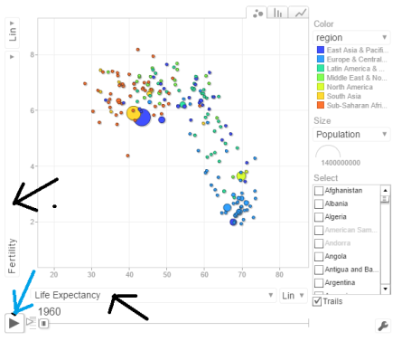](https://gigadom.wordpress.com/2016/09/18/analyzing-world-bank-data-with-wdi-googlevis-motion-charts/untitled-38/)

You can select Life Expectancy, Population, Fertility etc by clicking the black arrows. The blue arrow shows the ‘play’ button to set animate the motion chart. You can also select the countries and change the size of the circles. Do give it a try. Here are some quick analysis by playing around with the motion charts with different parameters chosen

a. **Life Expectancy vs Fertility chart**

This chart is used by Hans Rosling in his Ted talk. The left chart shows low life expectancy and high fertility rate for several sub Saharan and East Asia Pacific countries in the early 1960’s. Today the fertility has dropped and the life expectancy has increased overall. However the sub Saharan countries still have a high fertility rate

[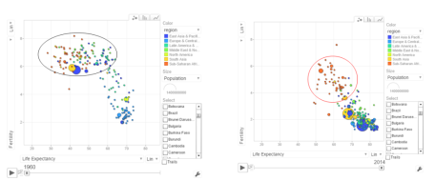](https://gigadom.wordpress.com/2016/09/18/analyzing-world-bank-data-with-wdi-googlevis-motion-charts/pic1-4/)

b. **Population vs GDP**

The chart below shows that GDP of India and China have the same GDP from 1973-1994 with US and Japan well ahead.

[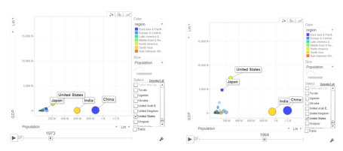](https://gigadom.wordpress.com/2016/09/18/analyzing-world-bank-data-with-wdi-googlevis-motion-charts/pic2-4/)

From 1998- 2014 China really pulls away from India and Japan as seen below

[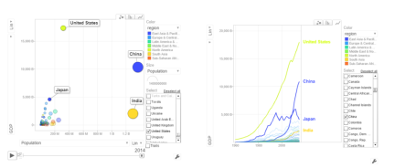](https://gigadom.wordpress.com/2016/09/18/analyzing-world-bank-data-with-wdi-googlevis-motion-charts/pic3-3/)

c. **Per capita income vs Life Expectancy**

In the 1990’s the per capita income and life expectancy of the sub -saharan countries are low (42-50). Japan and US have a good life expectancy in 1990’s. In 2014 the per capita income of the sub-saharan countries are still low though the life expectancy has marginally improved.

[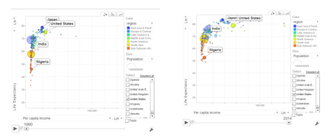](https://gigadom.wordpress.com/2016/09/18/analyzing-world-bank-data-with-wdi-googlevis-motion-charts/pic4/)

d. **Population vs Poverty headcount**

[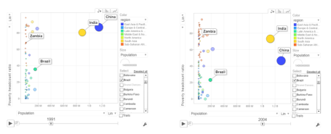](https://gigadom.wordpress.com/2016/09/18/analyzing-world-bank-data-with-wdi-googlevis-motion-charts/pic5/)

In the early 1990’s China had a higher poverty head count ratio than India. By 2004 China had this all figured out and the poverty head count ratio drops significantly. This can also be seen in the chart below.

[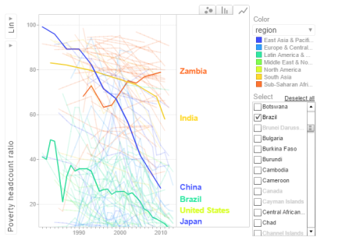](https://gigadom.wordpress.com/2016/09/18/analyzing-world-bank-data-with-wdi-googlevis-motion-charts/pop_pov3/)

In the chart above China shows a drastic reduction in poverty headcount ratio vs India. Strangely Zambia shows an increase in the poverty head count ratio.

**6.Get the data for the 2nd set of indicators**

1. Total population  – SP.POP.TOTL
2. GDP in US$ – [NY.GDP.MKTP.CD](http://NY.GDP.MKTP.CD)
3. Access to electricity (% population) – EG.ELC.ACCS.ZS
4. Electricity consumption KWh per capita -EG.USE.ELEC.KH.PC
5. CO2 emissions -EN.ATM.CO2E.KT
6. Basic Sanitation Access – SH.STA.BASS.ZS

# World population

population = WDI(indicator='SP.POP.TOTL', country="all",start=1960, end=2016)

# GDP in US $

gdp= WDI(indicator='[NY.GDP.MKTP.CD](http://NY.GDP.MKTP.CD)', country="all",start=1960, end=2016)

# Access to electricity (% population)

elecAccess= WDI(indicator='EG.ELC.ACCS.ZS', country="all",start=1960, end=2016)

# Electric power consumption Kwh per capita

elecConsumption= WDI(indicator='EG.USE.ELEC.KH.PC', country="all",start=1960, end=2016)

#CO2 emissions

co2Emissions= WDI(indicator='EN.ATM.CO2E.KT', country="all",start=1960, end=2016)

# Access to sanitation (% population)

sanitationAccess= WDI(indicator='SH.STA.ACSN', country="all",start=1960, end=2016)

**7.Rename the columns**

names(population)[3]="Total population"

names(gdp)[3]="GDP US($)"

names(elecAccess)[3]="Access to Electricity (% popn)"

names(elecConsumption)[3]="Electric power consumption (KWH per capita)"

names(co2Emissions)[3]="CO2 emisions"

names(sanitationAccess)[3]="Access to sanitation(% popn)"

**8.Join the individual data frames**

Join the individual data frames to one large wide data frame with all the indicators for the countries

j1 <- join(population, gdp)

j2 <- join(j1,elecAccess)

j3 <- join(j2,elecConsumption)

j4 <- join(j3,co2Emissions)

wbData1 <- join(j3,sanitationAccess)

**9.Use WDI_data**

Use WDI_data to get the list of indicators and the countries. Join the countries and region

#This returns list of 2 matrixes

wdi_data =WDI_data

# The 1st matrix is the list is the set of all World Bank Indicators

indicators=wdi_data[[1]]

# The 2nd matrix gives the set of countries and regions

countries=wdi_data[[2]]

df = as.data.frame(countries)

aa <- df$region != "Aggregates"

# Remove the aggregates

countries_df <- df[aa,]

# Subset from the development data only those corresponding to the countries

ee = subset(wbData1, country %in% countries_df$country)

ff = join(ee,countries_df)

## Joining by: iso2c, country

**10.Create and display the motion chart**

gg1<- gvisMotionChart(ff,

idvar = "country",

timevar = "year",

xvar = "GDP",

yvar = "Access to Electricity",

sizevar ="Population",

colorvar = "region")

plot(gg1)

cat(gg1$html$chart, file="chart2.html")

a. **Access to Electricity vs Population**  
**[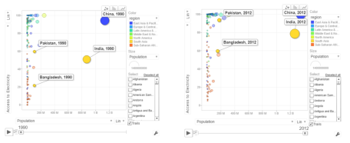](https://gigadom.wordpress.com/2016/09/18/analyzing-world-bank-data-with-wdi-googlevis-motion-charts/pic6/)**The above chart shows that in China 100% population have access to electricity. India has made decent progress from 50% in 1990 to 79% in 2012. However Pakistan seems to have been much better in providing access to electricity. Pakistan moved from 59% to close 98% access to electricity

b. **Power consumption vs population**

[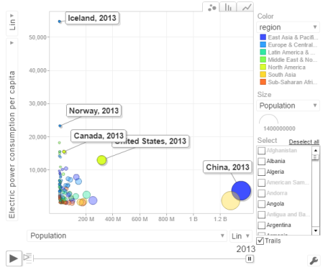](https://gigadom.wordpress.com/2016/09/18/analyzing-world-bank-data-with-wdi-googlevis-motion-charts/powercon/)

The above chart shows the Power consumption vs Population. China and India have proportionally much lower consumption that Norway, US, Canada

c. **CO2 emissions vs Population**

[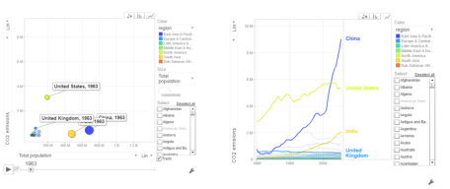](https://gigadom.wordpress.com/2016/09/18/analyzing-world-bank-data-with-wdi-googlevis-motion-charts/pic7/)

In 1963 the CO2 emissions were fairly low and about comparable for all countries. US, India have shown a steady increase while China shows a steep increase. Interestingly UK shows a drop in CO2 emissions

d.  **Access to sanitation**  
[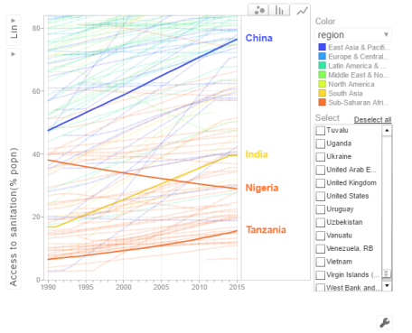](https://gigadom.wordpress.com/2016/09/18/analyzing-world-bank-data-with-wdi-googlevis-motion-charts/san/)

India shows an improvement but it has a long way to go with only 40% of population with access to sanitation. China has made much better strides with 80% having access to sanitation in 2015. Strangely Nigeria shows a drop in sanitation by almost about 20% of population.

**Conclusion**: So there you have it. I have shown some screenshots of some sample parameters of the World indicators.